Name: Archana Devi.P
Reg Number: 192521192
Course: Programming in Java
Code: CSA0923
Github Link: https://github.com/Archix17/CSA0923-JAVA
ASSIGNMENT 3

Q1 – Handling Failure in a Bank ATM Simulation
1. Aim
To implement an ATM withdrawal system using Java exception handling techniques such as try, catch, multi-catch, finally, throw, and throws.
2. Problem analysis
Possible failures in an ATM system:
Failure | Exception | Type
Letters entered instead of amount | InputMismatchException | Unchecked
Negative withdrawal | IllegalArgumentException | Unchecked
Amount exceeds balance | InsufficientFundsException | Checked (custom)
Card-reader file missing | IOException | Checked
JVM memory exhaustion | OutOfMemoryError | Error

3. Exception hierarchy
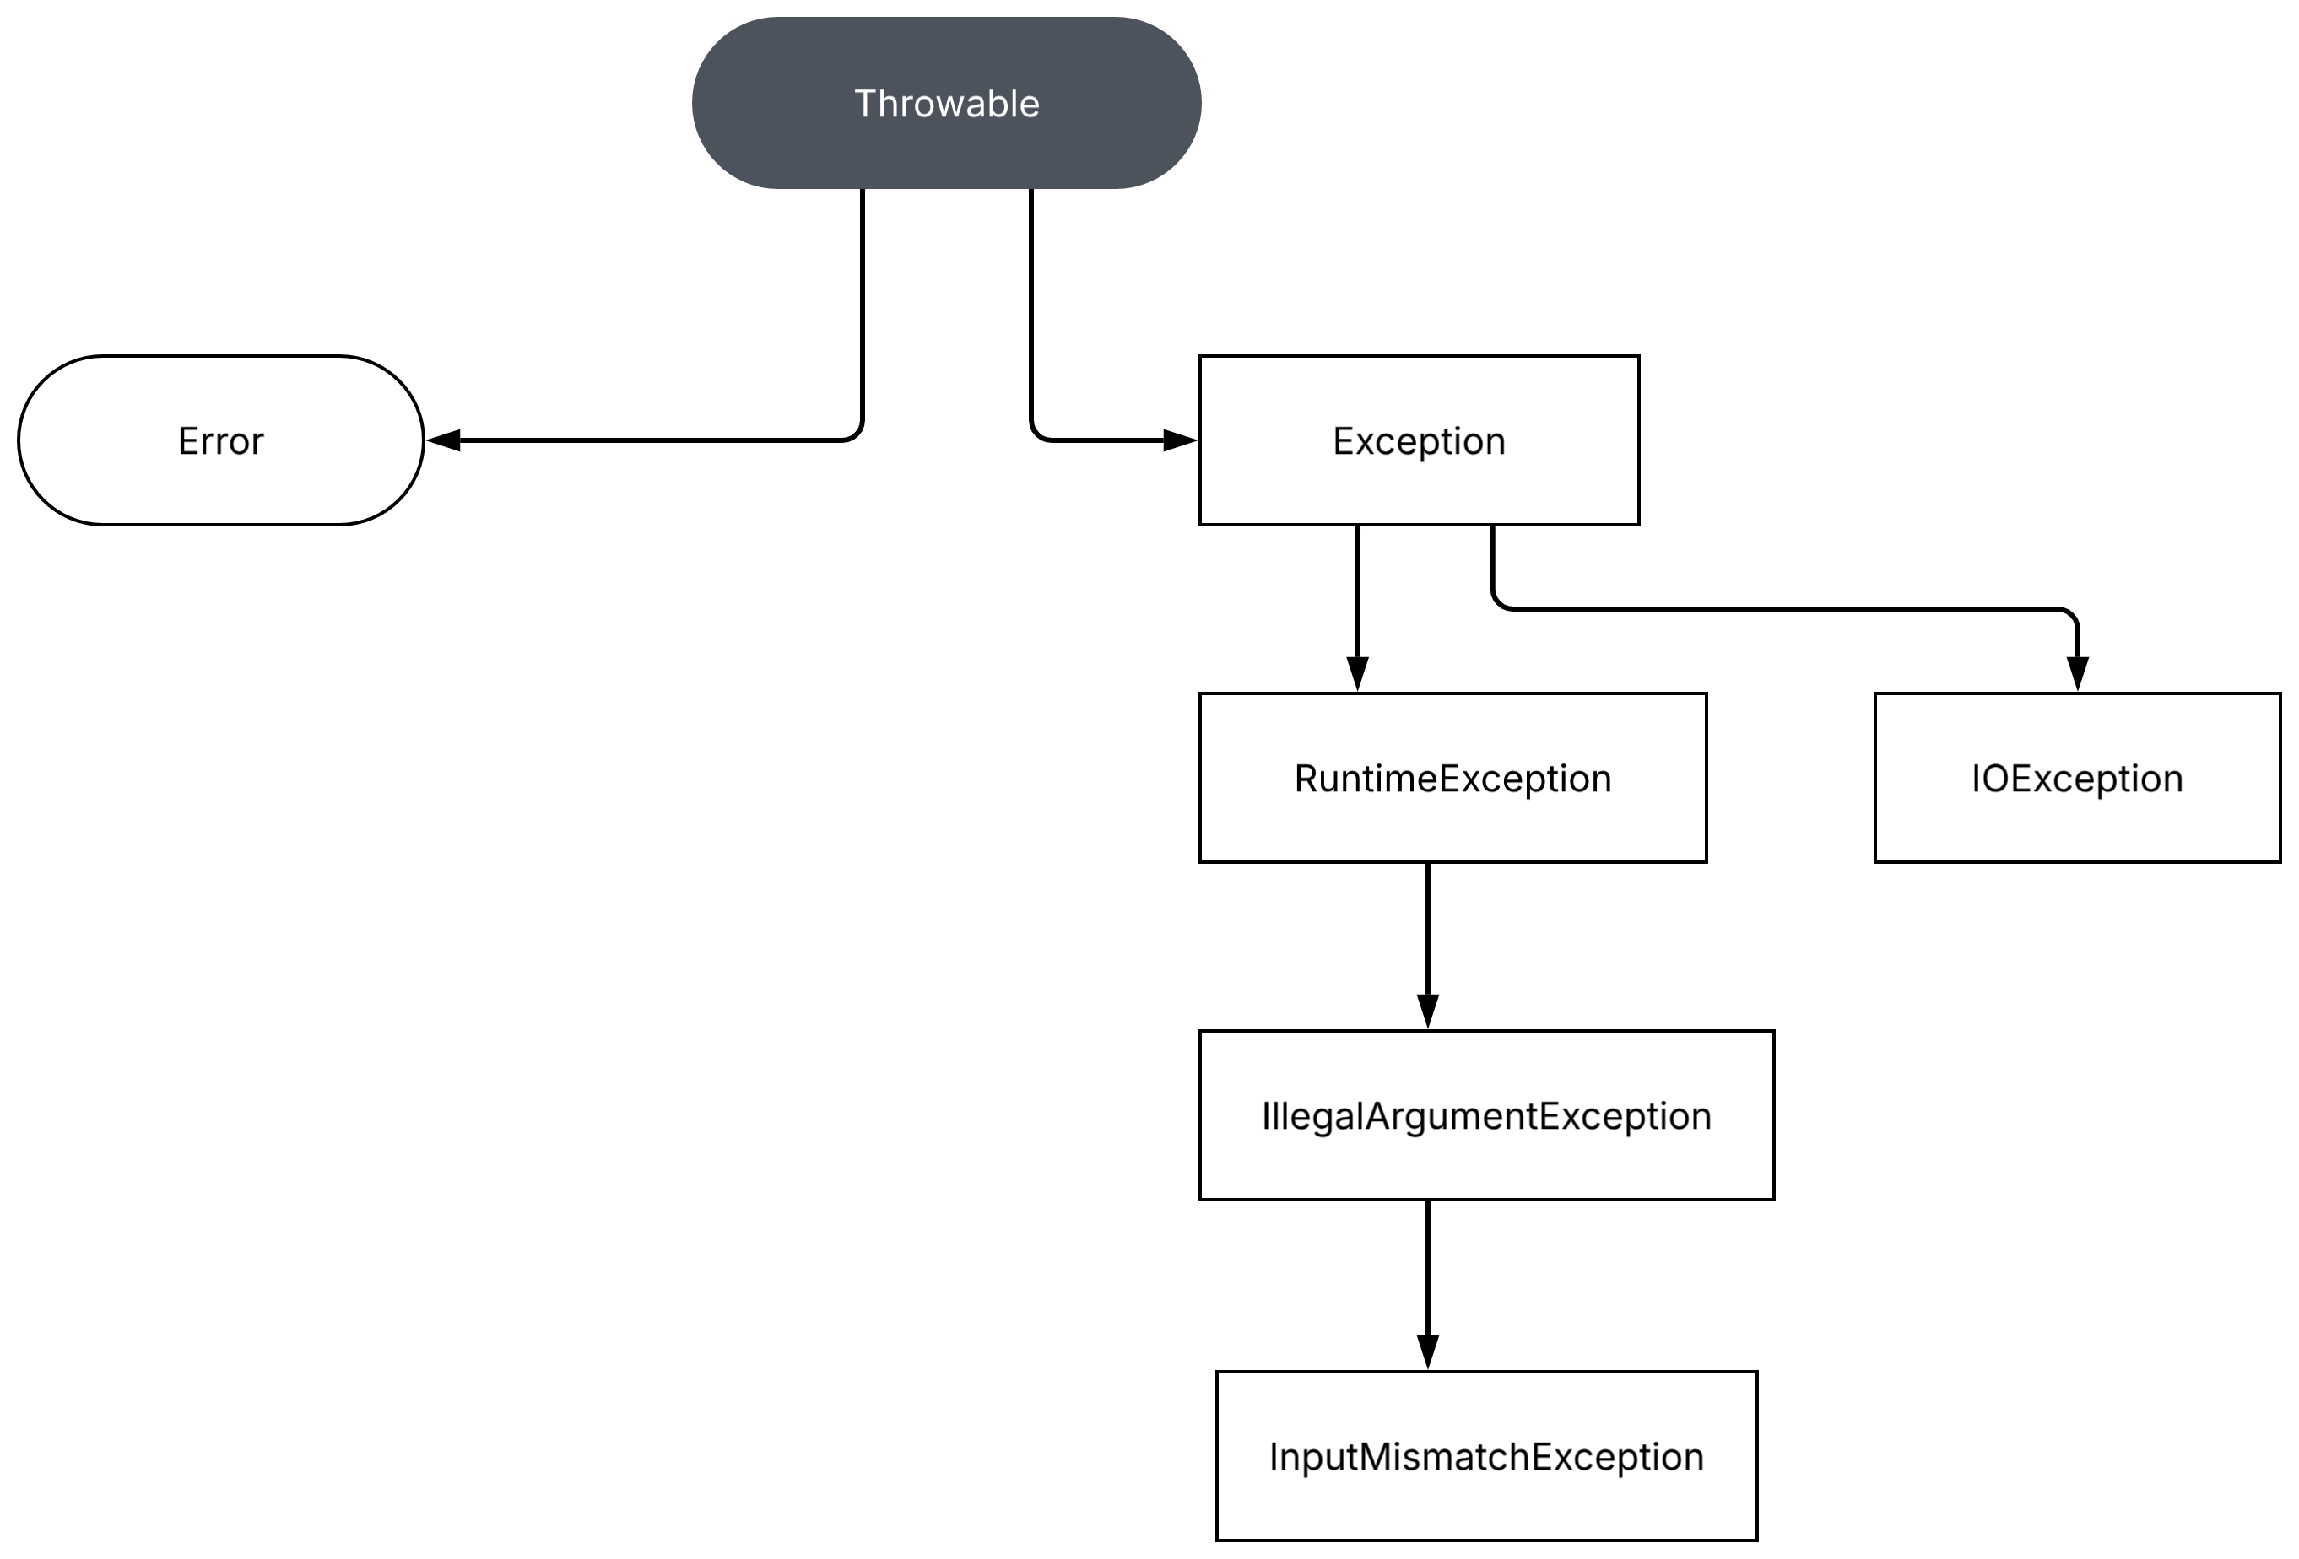
InsufficientFundsException is a custom checked exception extending Exception.
4. Algorithm
- Read the account balance.
- Read the withdrawal amount.
- Validate that the amount is positive.
- Check whether the amount is within the available balance.
- Check whether the card-reader file exists.
- Dispense cash if all checks pass.
- Catch the appropriate exceptions.
- Execute the finally block.
5. Java program
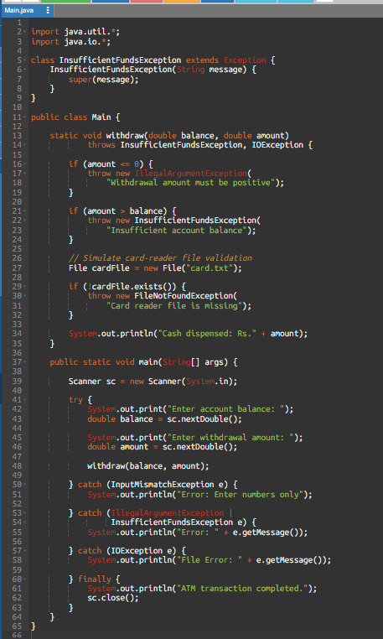
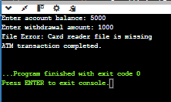
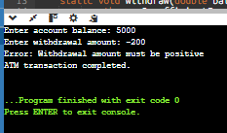
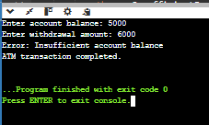
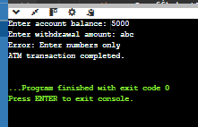
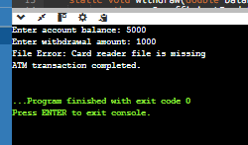

6. Alternative concept – Without exceptions
Instead of throwing exceptions, the program can validate every input using Scanner.hasNextDouble() and return status codes such as:
- 0 – Success
- -1 – Invalid amount
- -2 – Insufficient balance
- -3 – Missing card file
Complexity analysis:
Approach | Time | Extra space
Normal validation | O(1) per transaction | O(1)
Exception handling | O(1) for normal checks; stack-trace creation adds overhead on failure | O(1) per active exception, plus stack-trace data

Exception-based code is useful for exceptional situations. Returning error codes is suitable when failures are expected frequently and need regular handling.
7. Joint design question
- Should the ATM catch every exception using catch(Exception e)?
- Not usually. Specific exception handling provides clearer error messages and allows each failure to be handled differently. A broad catch can be acceptable at an application boundary for logging and preventing a crash, but it should not hide programming errors or replace appropriate recovery logic.
- Catch-block order: Specific exceptions must appear before broader exceptions. Otherwise, the broader catch makes later specific catches unreachable.
8. Conclusion
The ATM program demonstrates checked and unchecked exceptions, multi-catch, and finally. Specific exception handling makes the application safer and easier to debug.

Q2 – User-Defined Exceptions and Propagation in an Online Examination Portal
1. Aim
To implement custom checked exceptions and exception chaining across the controller, service, and storage layers of an online examination portal.
2. Problem analysis
The portal may reject submissions because:
- The examination window has closed.
- The student is not registered.
- The submitted answer file exceeds the allowed size.
3. Exception hierarchy
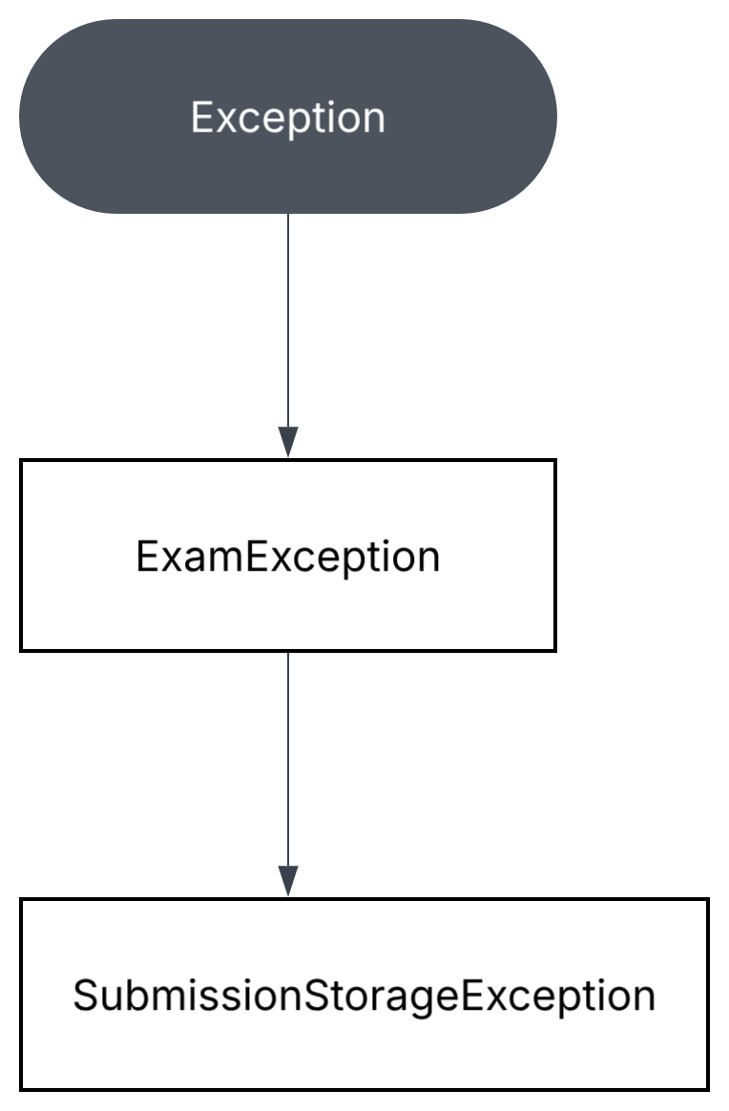
- Other possible custom subclasses include ExamClosedException and StudentNotRegisteredException.
- These are checked exceptions because the application is expected to handle these business and storage failures explicitly.
4. Algorithm
- Receive the answer-file submission.
- Validate the examination window.
- Validate student registration.
- Pass the file to the storage layer.
- Check the file-size limit.
- Catch the IOException.
- Wrap it in a SubmissionStorageException.
- Preserve the original exception using the cause constructor.
- Handle the exception in the controller.
5. Complete the Code – TODO 1
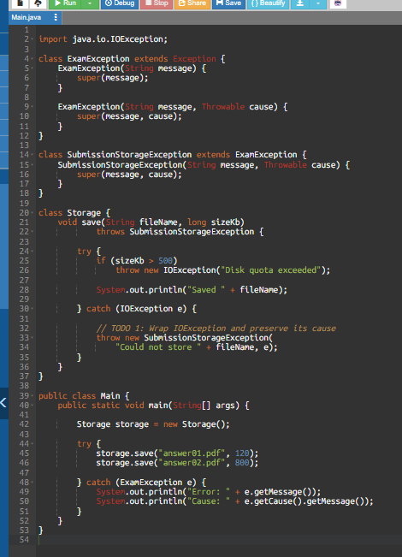
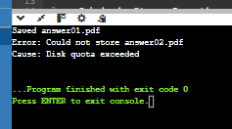
7. Exception propagation
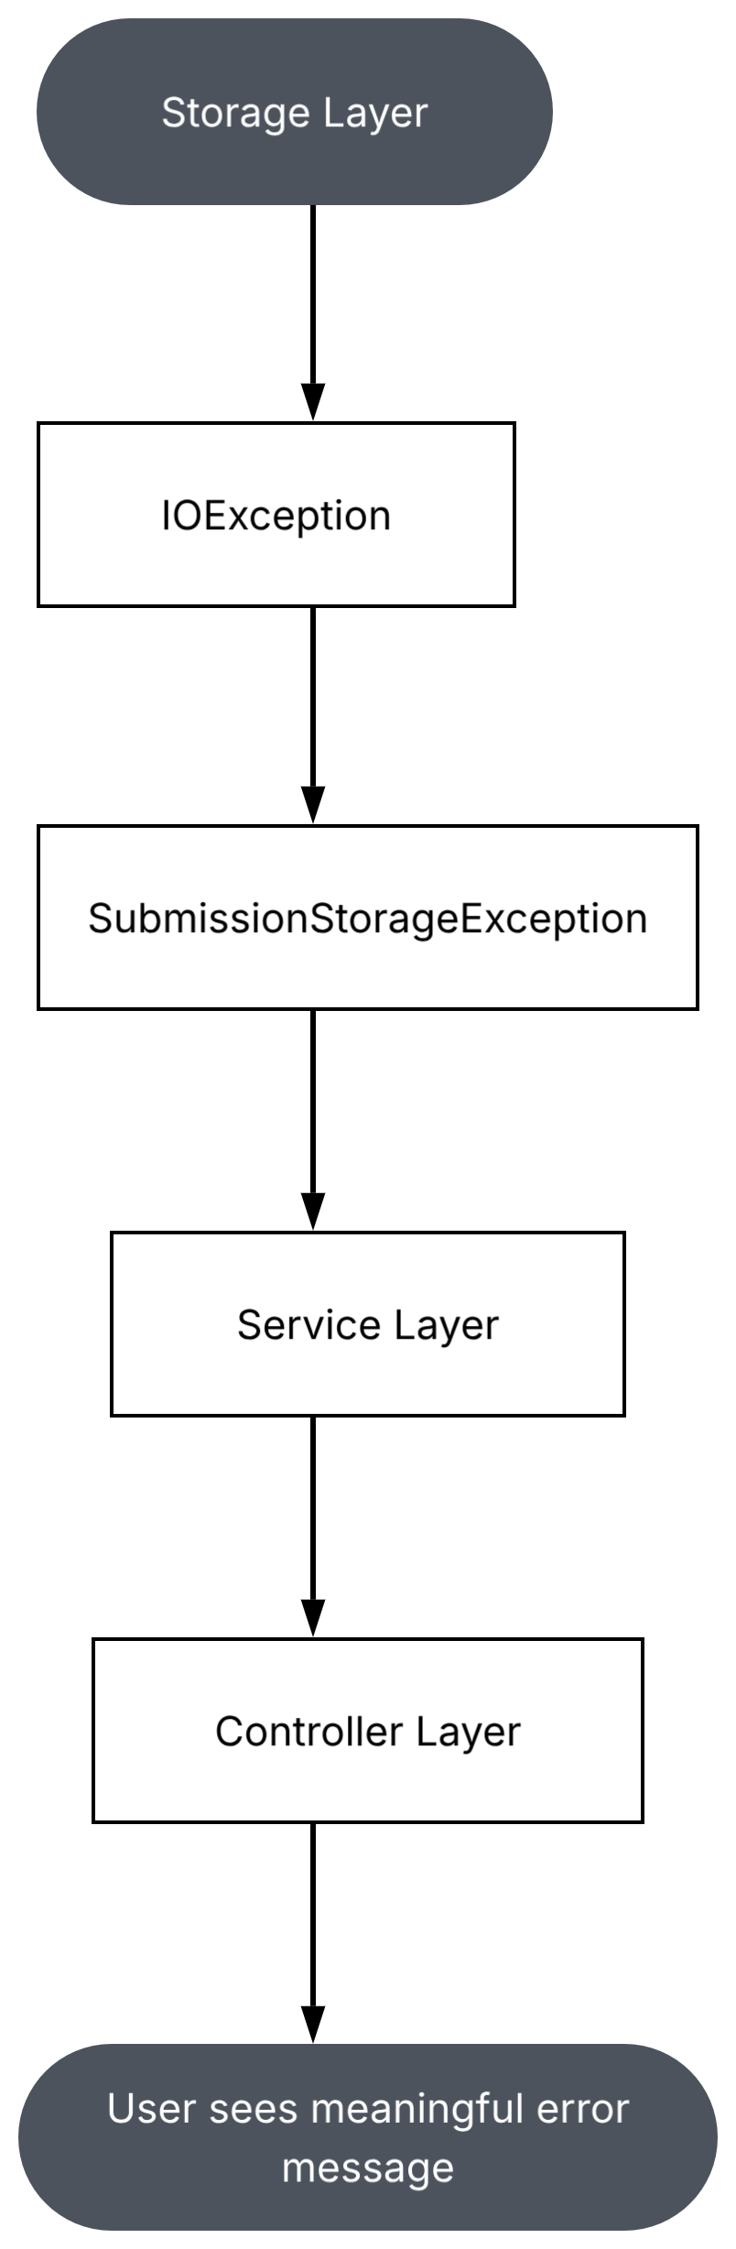
- The storage layer should throw a meaningful SubmissionStorageException instead of exposing a low-level IOException directly to the user interface.
- This separates technical implementation details from application-level error handling.
8. Alternative concept – Unchecked exceptions
If custom exceptions extended RuntimeException instead of Exception:
- The methods would not be required to declare them using throws.
- Calling methods would not be forced to catch them.
- The programmer would have more flexibility.
- Important failures could go unhandled until runtime.
Complexity analysis:
- Creating an exception and capturing its stack trace takes time proportional to the stack depth, approximately O(d), where d is the number of stack frames.
- The exception also stores message and stack-trace information, requiring O(d) additional space.
- Chaining retains a reference to the cause exception and its stack trace, increasing memory use.
9. Conclusion
Custom checked exceptions provide meaningful error handling. Exception chaining preserves the original cause, making debugging easier and improving error reporting across application layers.
Q3 – Resource Safety, Debugging and Robust Code
1. Aim
To implement a daily sales report generator using manual resource closing and try-with-resources, and compare their reliability.
2. Problem analysis
The report generator reads multiple store files and writes a summary file. If an exception occurs before a file is closed, the program may leak file handles.
Resources that must be closed:
- Input file readers.
- Output file writers.
- Any other opened streams.
3. Algorithm
- Read sales data from multiple store files.
- Calculate the total sales.
- Write the summary into an output file.
- Handle file-related exceptions.
- Close every opened resource.
- Compare manual closing with try-with-resources.

4. Java program – Try-with-resources
Creating two input files named store1.txt and store2.txt, each containing a number representing sales. For example, 1000 and 2000.
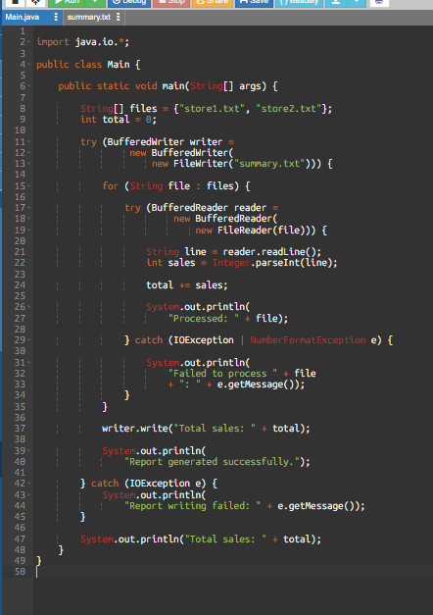
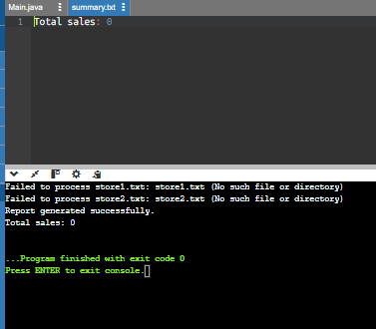
If one file is missing or corrupt, the program reports that failure and continues processing the remaining files.
6. Manual closing versus try-with-resources
- Manual closing requires explicit close() calls, usually in a finally block.
- Try-with-resources automatically closes resources when execution leaves the try block, even if an exception occurs.
- When multiple resources are declared, they are closed in reverse declaration order.
- Suppressed exception: If an exception occurs while the try block is running and another exception occurs while closing a resource, the closing exception is recorded as a suppressed exception.
7. Alternative concept and complexity analysis
Method | Resource safety
Manual close in finally | Requires careful coding
Try-with-resources | Automatically closes resources
No closing | Can cause file-handle leaks

For f files containing a total of N characters or records:
- Processing time is O(N).
- Processing files sequentially requires O(1) simultaneously open input files, plus the output file.
- A faulty implementation that opens all f files without closing them can hold O(f) file handles.
- Try-with-resources keeps the number of simultaneously open files bounded when each input file is processed in its own resource scope.
Joint engineering decision: Try-with-resources is not sufficient by itself if the program does not validate data, recover from corrupt files, handle disk-full conditions, or verify that the report was completely written.
8. Conclusion
Try-with-resources improves resource safety by automatically closing files. It prevents many file-handle leaks and makes the report generator more reliable than manual resource management.

Q4 – Thread Creation and the Thread Life Cycle
1. Aim
To implement parallel answer-script scanning using Java threads and compare extending Thread with implementing Runnable.
2. Problem analysis
Four scanner stations process answer scripts simultaneously. Each station runs independently and reports how many scripts it scanned.
3. Algorithm
- Create four scanner stations.
- Implement one version by extending Thread.
- Implement another version using Runnable.
- Start each station using start().
- Use sleep() to simulate scanning.
- Use isAlive() to check whether a station is running.
- Use join() to wait for all stations.
- Calculate the final total.
4. Java program – Thread and Runnable
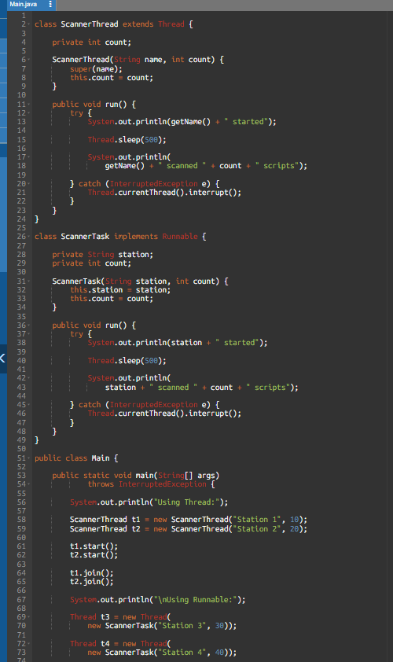
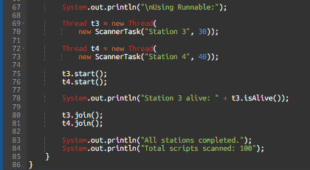
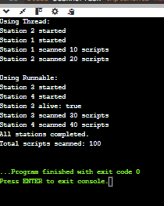
Java officially groups the running and ready-to-run states under RUNNABLE.
7. Thread versus Runnable
Extending Thread | Implementing Runnable
Class extends Thread | Class implements Runnable
Cannot extend another class | Can extend another class
Task and thread are combined | Task and thread are separate
Less flexible for reuse | Better task reuse

- Why use start() instead of run()?
- start() creates a new execution thread and then invokes run(). Calling run() directly executes it like an ordinary method in the current thread.
- Why use join()?
- join() makes the main thread wait until the selected worker thread finishes. Therefore, the final total is printed only after all stations complete.
8. Alternative concept – ExecutorService
Instead of manually creating four Thread objects, a fixed thread pool can be used:
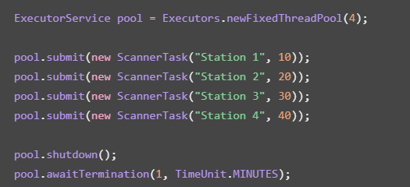
- For n scripts and p workers, the ideal processing time is approximately O(n/p), assuming balanced work and sufficient resources.
- Each worker uses a thread stack, so p threads require approximately O(p × stack size) stack memory. An executor reuses threads and is generally more manageable for larger workloads.
9. Behavioural experiments
- Run the program ten times and record the station completion order. Also test changing thread priorities and making one station a daemon thread.
- Do not expect priorities to guarantee an execution order. The thread scheduler decides which runnable thread gets CPU time. A daemon thread does not keep the JVM alive after all user threads finish.
10. Conclusion
Both Thread and Runnable can implement parallel scanning. Runnable provides better separation between the task and its execution thread. The join method ensures the final result is printed only after all stations finish.
Q5 – Race Conditions in a Cinema Seat-Booking System
1. Aim
To demonstrate race conditions in a cinema seat-booking system and prevent double booking using synchronization.
2. Problem analysis
A seat is booked through two operations:
- Check whether the seat is available.
- Mark the seat as booked.
- If two threads perform these operations at the same time, both may see the seat as available and book it.
- This is called a race condition.
3. Algorithm
- Create a boolean array to represent seats.
- Create 100 user threads.
- Allow each thread to compete for one seat.
- Run the program without synchronization.
- Record the number of successful bookings.
- Add synchronization to make check-and-book atomic.
- Repeat the test ten times.
- Compare both results.
4. Complete the Code – TODO 1
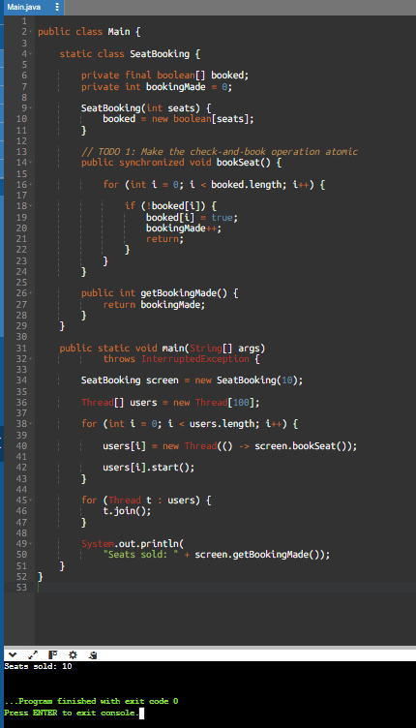
Only ten seats are available, so no more than ten successful bookings are possible.
6. Unsynchronized version
For the first experiment, remove synchronized from the method declaration:
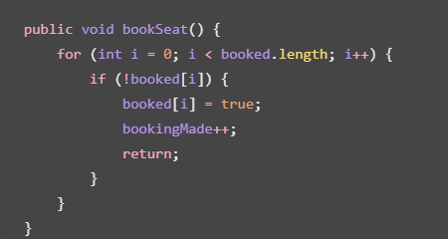
- Run the unsynchronized version ten times and record the results. It may sometimes produce more than ten successful bookings because multiple threads can read the same available seat before either marks it as booked.
- Important: A race condition is not guaranteed to appear in every execution. If all ten runs happen to show ten, record that honestly; the absence of a reproduced failure does not prove the code is thread-safe.
7. Synchronized method versus synchronized block
Synchronized method:
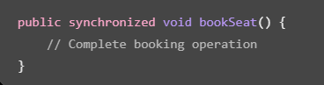
Synchronized block:
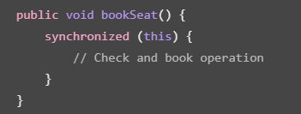
Both use the intrinsic lock of the current object. The synchronized block is useful when only a small part of a method needs locking.

8. Alternative concept – AtomicBooleanArray
The seat state could be represented using AtomicIntegerArray and compareAndSet():
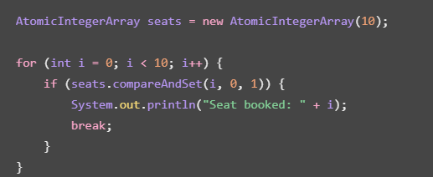
compareAndSet() atomically changes a seat from 0 (available) to 1 (booked).
Approach | Time per booking attempt | Space
Synchronized search | O(s) | O(s)
AtomicIntegerArray search | O(s) | O(s)

Here, s is the number of seats. The atomic approach avoids locking the entire object, but a full booking system may still require additional coordination for payment, reservation expiry, and customer details.
9. Joint engineering decision
- For a cinema with 20 screens, I would use a separate booking object and lock for each screen or seat group.
- This allows different screens to process bookings concurrently while preventing two customers from booking the same seat.
10. Conclusion
- The race condition occurs because checking and booking are not atomic operations.
- Synchronization prevents double booking by allowing only one thread at a time to execute the critical section.
Q6 – Deadlock and Inter-Thread Communication
1. Aim
To demonstrate deadlock in hostel wallet transfers and implement a producer-consumer system using wait(), notify(), and notifyAll().

2. Problem analysis
This question has two parts.
- Part A – Hostel wallet transfers
Two students transfer money between wallets. Each transfer locks both wallet accounts. If two threads acquire the locks in opposite orders, deadlock can occur.
- Part B – Mess token counter
A producer prepares mess tokens, and students consume them. The counter can hold a maximum of five tokens.
3. Part A – Deadlock demonstration
Algorithm:
- Create two wallet objects.
- Create two transfer threads.
- Make the first thread lock wallet A and then wallet B.
- Make the second thread lock wallet B and then wallet A.
- Both threads can wait indefinitely for the lock held by the other.
Java program – Deadlock and prevention
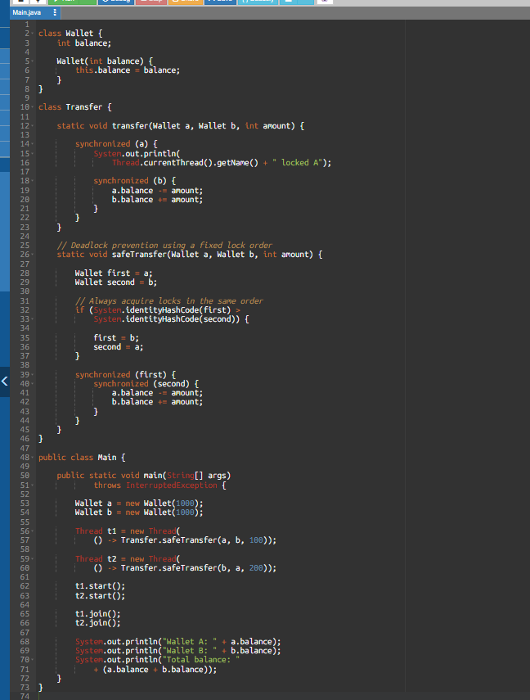
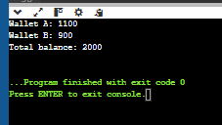
The total balance remains unchanged.
4. Part B – Producer-consumer design
The buffer can store a maximum of five tokens.
- Producer waits when the buffer is full.
- Consumer waits when the buffer is empty.
- notifyAll() wakes waiting threads when the buffer state changes.
- while conditions are used to recheck the buffer after waking.
Complete Java program – TODO 1 and TODO 2
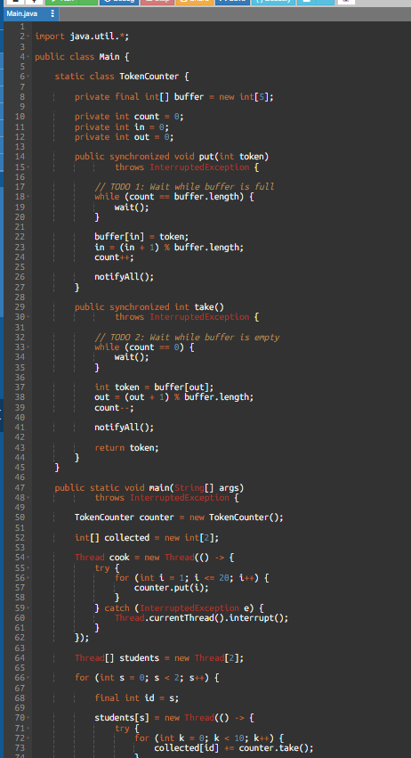
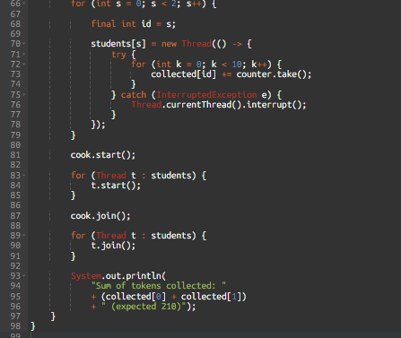
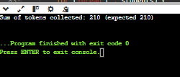
5. Why use while instead of if?
A thread can wake up even when the required condition is not satisfied. Therefore, the program checks the condition again using while.
- wait() releases the object's monitor lock while waiting.
- notify() wakes one waiting thread.
- notifyAll() wakes all waiting threads.
- The awakened thread must reacquire the monitor before continuing.
6. Alternative concept – ArrayBlockingQueue
Instead of manually implementing wait() and notifyAll(), Java provides ArrayBlockingQueue.
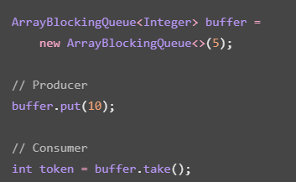
Operation | Manual synchronized buffer | ArrayBlockingQueue
Put | O(1) | O(1)
Take | O(1) | O(1)
Space | O(5) | O(5)

Both have bounded storage. ArrayBlockingQueue is generally less error-prone because it handles blocking and notification internally.
7. Conclusion
- The wallet example demonstrates how inconsistent lock ordering can create deadlock. Consistent lock ordering prevents that problem.
- The producer-consumer implementation uses wait and notifyAll to coordinate threads while maintaining a bounded buffer.
Q7 – Design a Concurrent, Fault-Tolerant Processor from First Principles
1. Aim
- To design and implement a concurrent result-processing system using ExecutorService, Callable, Future, and concurrent collections.
- The system processes 10,000 answer-script files while handling missing and corrupt files without stopping the entire run.
2. Stage 1 – Interpret the problem
The examination cell must:
- Process 10,000 answer-script files.
- Read and validate each file.
- Calculate the total score.
- Handle missing files.
- Handle corrupt files.
- Continue processing when one file fails.
- Generate a final success and failure summary.

Parallel and shared operations
Operation | Type
Reading individual files | Parallel
Validating individual scores | Parallel
Calculating individual results | Parallel
Updating total success count | Shared
Updating total failure count | Shared
Producing final summary | After all tasks finish

Measurable requirements:
- All 10,000 files must be attempted.
- One file failure must not stop the other tasks.
- Every file must be counted as either successful or failed.
- The final summary must match the expected test results.
- Processing time must be measured using 1, 2, 4, and 8 threads.
3. Stage 2 – Design
Proposed design:
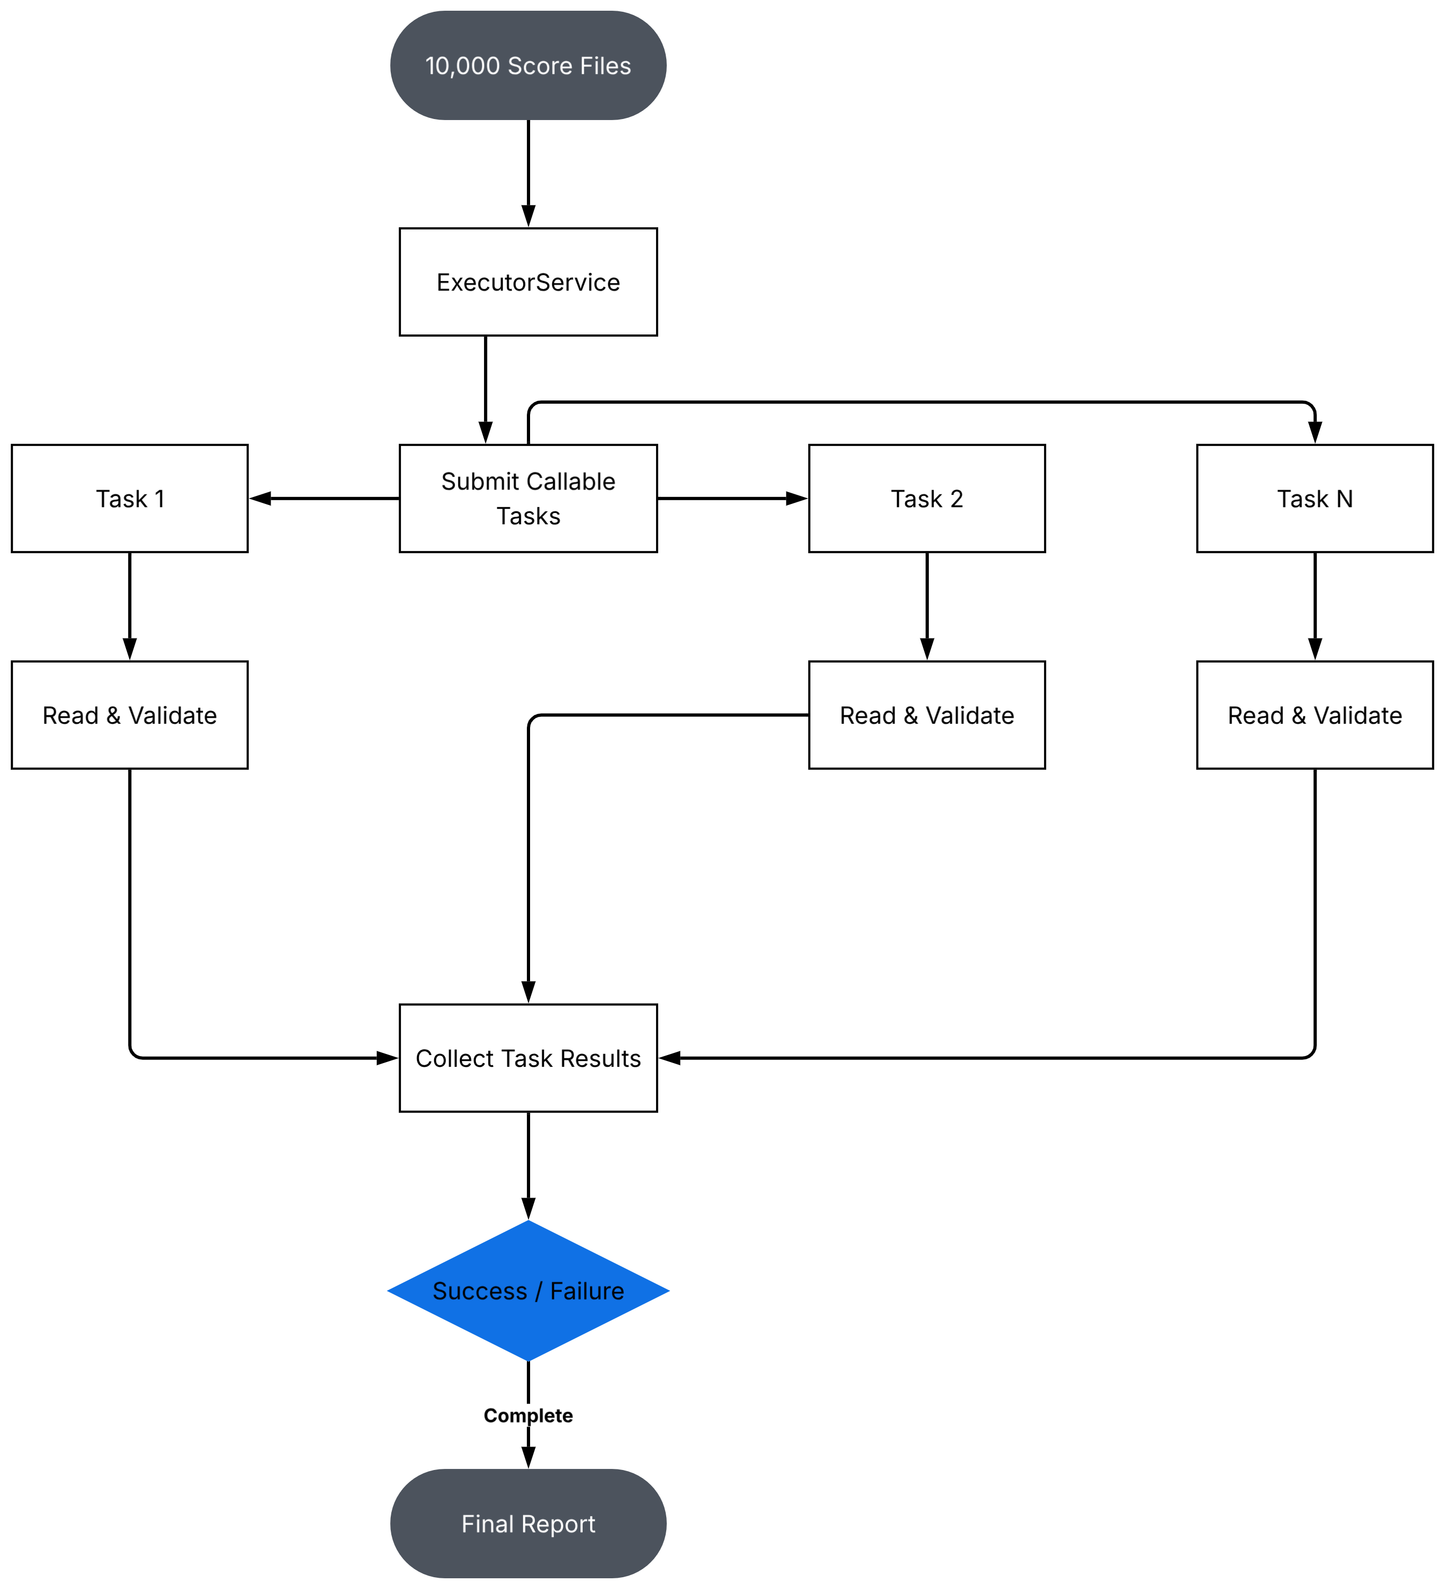

- Why ExecutorService?
It manages a fixed number of worker threads and avoids creating a separate thread for every file.
- Why Callable?
Callable allows each task to return a result and report exceptions through Future.
- Why concurrent collections?
Concurrent collections support safe access by multiple threads without requiring us to implement all synchronization manually.
4. Stage 3 – Complete Java program
This program creates 10,000 sample files in a temporary directory. It deliberately includes one missing file and one corrupt file, then processes the files using thread pools of 1, 2, 4, and 8 workers.
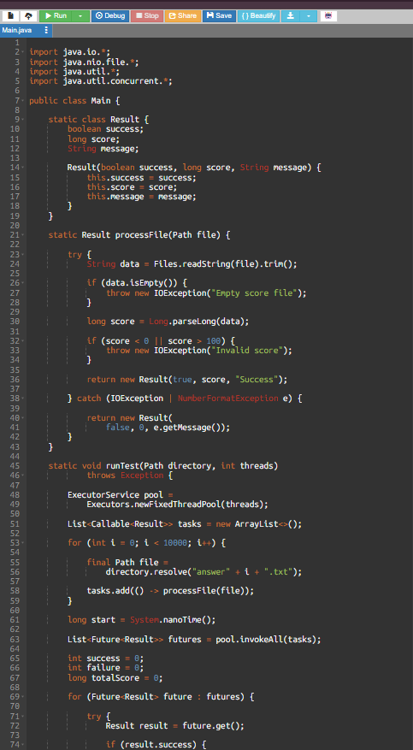
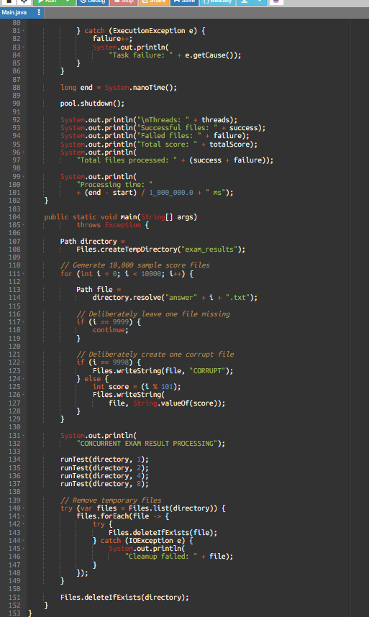
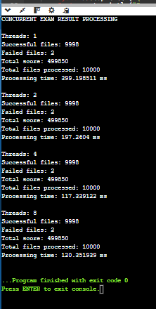
7. How does the design handle failure?
- Each task catches expected file-reading and validation failures and returns a failure result instead of terminating the entire processing run.
- The main thread collects the results using Future. If an unexpected task exception occurs, it is handled through ExecutionException.
- The final summary counts successful and failed files separately, so a missing or corrupt file does not stop the other tasks.
8. Alternative concept and complexity analysis
Alternative A – Parallel streams
- Instead of ExecutorService, files could be processed using:
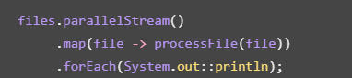
- Parallel streams use the common ForkJoinPool by default. They are convenient, but provide less direct control over the thread pool.
Alternative B – One thread per file
- Creating 10,000 threads would consume much more memory and scheduling resources.
Approach | Time | Thread-related memory
ExecutorService | Depends on I/O and available workers | O(p × stack size)
Parallel stream | Depends on common pool size | O(p × stack size)
One thread per file | High scheduling overhead | O(n × stack size)

- Here, n is the number of files and p is the number of worker threads.
- The file-processing work is O(N) for N total input characters or records. For balanced work, ideal parallel processing time is approximately O(N/p), but real performance also depends on disk speed and overhead.
9. Remaining limitations
- The program stores all task objects and Future references in memory.
- It does not persist the summary if the JVM crashes.
- It uses a temporary directory for demonstration.
- A production application should use a database or durable result store and support retries for transient failures.
- A production design should also log the exact filename and failure reason.
10. Conclusion
- The concurrent result processor uses ExecutorService and Callable to process answer-script files in parallel.
- Future collects task results, while individual file failures are handled without stopping the entire run.
- The final summary provides the number of successful and failed files, making the design more fault-tolerant.

